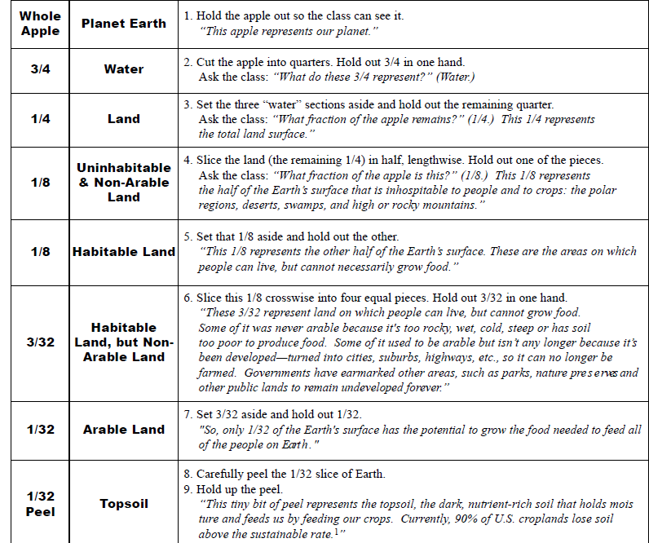
APPLE-SOIL INTEREST APPROACH

