**SOIL TEXTURE TRIANGLE**

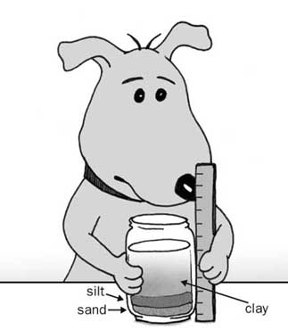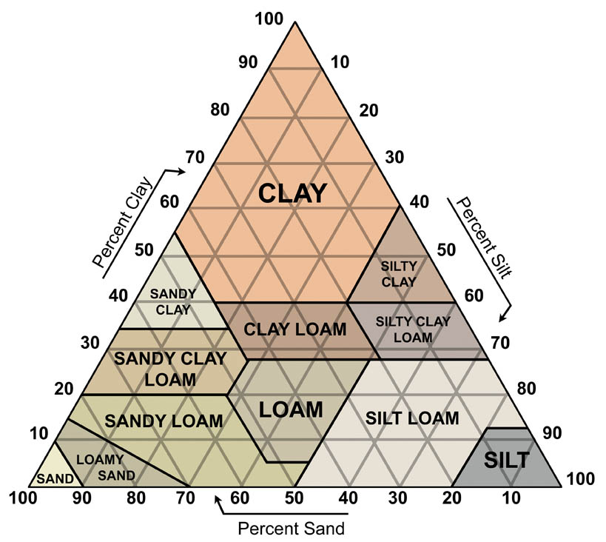

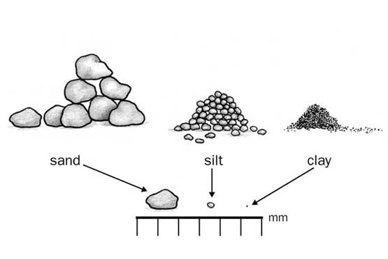

[](http://www.google.com/url?sa=i&rct=j&q=&esrc=s&source=images&cd=&cad=rja&uact=8&ved=0ahUKEwiwkd_Kh_rTAhVrBMAKHYFdBbcQjRwIBw&url=http://www.wilx.com/content/misc/Brown-Fertilizer-415712683.html&psig=AFQjCNEYPXoPJ9i8G-qW8Mos2Zg9FgoRsg&ust=1495218085382089)

