Instructions for Creating Your DIY Worm Composter

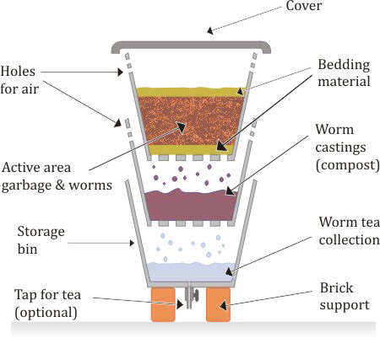

Cross sectional diagram of Three Bin Composter

The Sump

The lower sump bin is configured differently from the upper bins and would be prepared first. Its function is to collect excess fluid leachate, called worm tea or compost tea.

- The sump may be fitted with a 3/8 inch (15mm) barrel tap, through a small hole drilled in the base for conveniently draining out the excess fluid (the worm tea) that will accumulate there. This tap is not essential, but would avoid the otherwise potentially messy job of having to tip the worm tea out by rotating the bin.
- If you do decide to put in the tap, make sure it seals well in the hole, by providing good washers and lock nuts.

The Composting Bins

The two upper bins will actually hold the worms. They are to be identical and are prepared as follows:

- Drill a pattern of ¼ inch (6mm) holes across the entire base of each container for drainage and to allow for ventilation and the upward migration of the compost worms, these holes should be regularly spaced at approx. two inch (50mm) centers apart in either direction.
- For further aeration, drill a row of ¼ inch (6mm) holes at two inch (50mm) centers, in a continuous line around the walls of each of the bins. This line of holes would be about four inches (100mm) below the top rim of the bin.
- It is not essential to drill holes in the lid, which is closed tightly over the upper bin. as you should get enough air through the sides.

Setting It Up

After preparing your bins, you first set up the lower (sump) bin on bricks or blocks, allowing enough space to tap off the fluid from beneath it. Choose a shady location for the worm farm (in a shed or garage, if you are subject to frosts).

- The second and third bins are “nested” within each other and dropped into the sump bin. To maintain a working space for the worms, and for accumulation of compost, you need a few spacers or packers of about six to eight inches height, between the two upper bins and some smaller packers of about four inches in the lower (sump) bin. You can use wood blocks or sealed food jars for packers.
- The packers also prevent the tapered worm bins from jamming together and cause a gap between the bins, which improves ventilation.
- To prevent “nasty bugs” from squeezing in between the bins, you should close (caulk) the small gap between them with strips of shade cloth, or mosquito netting.

Starting Production

Now you are ready to go into production:

- Set up your worms in the top bin with a good (damp) fibrous bedding such as coconut coir, (or just shredded newspaper), put in a little compost and a handful or two of damp soil with the worms and after a few days you will be ready to start feeding in your kitchen scraps. Cover the food with more bedding material to discourage pests and keep the lid closed.
- Make sure the worm farm is never allowed to dry out, by sprinkling water over the bedding periodically, if there is not already enough moisture coming from the food scraps.
- When the top bin has been fully productive for a while, the worms will multiply and compost will be start accumulating from the worm castings. When the quantity of compost is meaningful, stop putting feed into this bin and swap over the upper two bins by putting bin No 2 to the top of the stack, with bin No 1 now in the middle.
- Set up this new top bin with clean bedding, a small amount of the old castings and immediately start feeding your kitchen scraps into it. Over a few days, the worms will naturally migrate upwards towards the new food source, leaving the lower bin with only a few stragglers and it should be ready for the harvesting of your compost within about three weeks after the swap.
- To get at any specific layer, to add food, bedding or to remove the vermicompost, just lift off all the overlying worm bins, one by one until the desired level is exposed for examination and then replace them in the same order. They will not be too heavy – but don’t try lifting more than one layer at a time, unless you have a good chiropractor!

All you need to do is to keep repeating the process of alternating the top two bins on a regular basis, taking out the compost, whenever it accumulates, and tapping off the worm tea from time to time. This worm tea, is a very valuable product as it is a highly concentrated liquid fertilizer that can be diluted for immediate use on your garden

*** This information was found at http://working-worms.com/how-to-make-your-own-worm-farm/
*** Please check the website above for more information on vermicomposting

