VERMICOMPOSTING
How to become a Worm Wizard

Getting Started:
You can get as fancy as a cedar compost bin or as simple as a plastic storage bin, but you need a container.

The size should equal about 1 cubic foot per person in the household. Something that can fit under the sink is perfect for a small family. Long and wide is better than a tall and narrow bin.

Use a drill or a hammer and nail to poke plenty of air holes in the lid top. (Many people puncture holes at the bottom to allow drainage and collect the compost “tea,” but some people manage the moisture added, to minimize a possible mess.)

What to Add:
Add shredded paper, food scraps and worms (about a 1 lb. ball with some compost or a large handful) to the bin, and cover it. Try to keep about a 70:30 ratio of brown matter to green matter (Brown is paper and dead material; Green is food scraps and young plants).

CAN Compost with Worms | CANNOT Compost with Worms
- food scraps (melon rinds, roots, stems, leaves, cores, husks, seeds, skins, peels, etc.)  - egg shells (not the egg protein), seaweed and rinsed seashells (like oyster shells; not shrimp peels)  - old natural fiber clothing (old t-shirts, socks, boxers, etc.)  - natural yarn, twine and string  - non-glossy paper products (cardboard boxes, newspapers, magazine inserts, most junk mail, envelopes, etc.)  - tea leaves and bags, coffee grinds and filters  - dead plants, grass clippings, pine needles and leaves  - natural non-treated wood and byproducts like wood ash, sawdust and shavings (no coal ash)  - feathers and hair (human, cat, dog, etc.)  - dryer lint  - produce that is wilted or browned and slightly rotten (not to the point of moldy) | - meat, fats, grease, bones or oils (no butter, lard, stocks, soups, etc.)  - plastics and plastic coated paper (like glossy magazines)  - stickers, including veggie stickers (remove stamps from envelopes)  - bread or yeast products (no crackers or cakes)  - salt, pepper, and other spices (or VERY limited amounts)  - milk, dairy, or dairy products  - cat or dog droppings  - lemon, lime, orange or other citrus peels and juice (in excess this will make the soil too acidic)  - onions and garlic (a good rule of thumb is if it makes you smell, it makes your worm bin smell)  - diseased or infested plants  - treated wood products
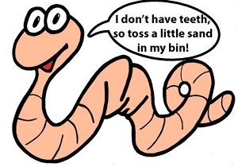
How to Maintain it:
About once a week, or every other week, move the material in the bin
around to help with aeration. Always keep a layer of shredded paper or
sawdust over the top of the pile to discourage smells and bugs.

Once you stop adding new material, the compost should be ready to harvest in
1 to 2 months (depending on how much is added in the last feeding).

(The information from this handout was found at http://www.sustainabletable.org/114/vermicomposting-101)
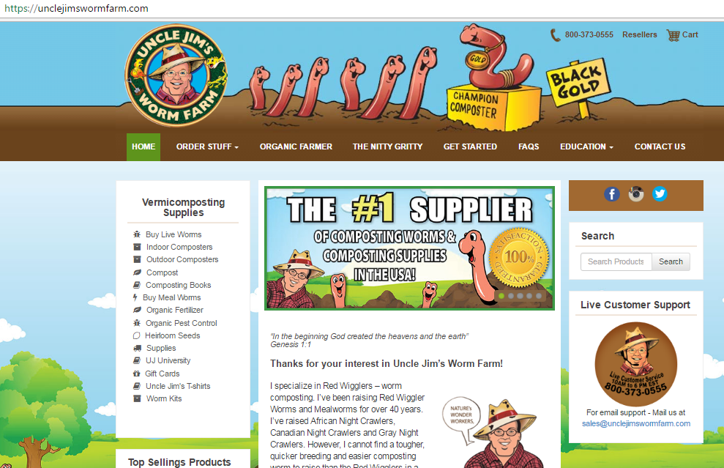
More Info on Vermicomposting:
Look up Uncle Jim’s Worm Farm online. They have a lot of information about worms, vermicomposting and how to buy your worms or supplies.

Thank you for visiting the IQhub and learning about Vermicomposting with us today!!!

