How to Make Bonfire Dinners

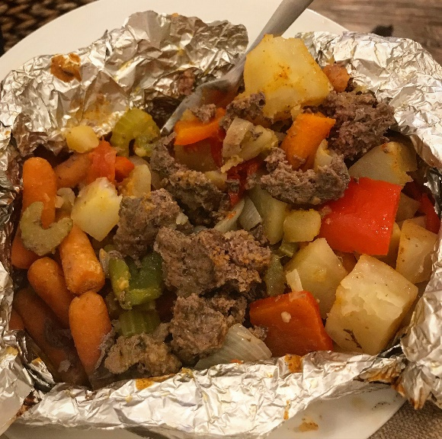
Materials:
- 1 or 1 ½ pounds of hamburger
- 2 or 3 carrots
- 2 or 3 red skin potatoes
- 1 roll of tin foil
- 1 stick of butter
- 1 knife
- 1 set of tongs
- Forks for everyone eating
- Plates for everyone eating

Procedure:
- Start a bonfire and make sure you get some good coals to work with
- Brown up the hamburger
- Wash, peel and cut up the carrots (thinner slices are better)
- Wash and cut up the red skin potatoes (thinner slices are better)
- Cut off 2 sheets of tin foil, each about 2 feet long
- To the center of one sheet of tin foil, add hamburger, carrots and potatoes
- Cut off 2 or 3 small pads of butter and place on the hamburger and vegetable
- Flatten the hamburger and vegetables down with your fork
- Fold up the sides of the tin foil, so it makes a sealed and tight package
- Flip tin foil package over, on the second sheet of tin foil, so that the folds are facing down
- Fold up the sides of the second sheet of tin foil, so it makes a sealed and tight package
- Place your tin foil package flat in the fire, on the coals for 10 – 15 minutes
- Take your tongs and flip your tin foil package, then let it cook on that side for 10 – 15 minutes
- Take your tongs and remove from fire and carefully open up onto your plate, to enjoy

*** Some people add different vegetables and spices to their tin foil before they make their meals. Also, some people use other food items and sauces, after they have cooked their tin foil packages, like cheese, tortillas and barbeque sauce. You can make bonfire dinners however you like! ***

